The Story of Numbers

PRE-REQUISITES: The first four Great Stories

This story opens up the Mathematics subject area. It comes AFTER “The Ox and the House”. It should be told early in the school year. After we’ve told the story, we can re-tell it with modifications, elaborations, and activities.

Homeschool adaptation: This is a very long story, so one alternative is to break it down into sections and tell it over a number of days or weeks (exploring one section per week).

Direct Aims:
- To arouse the interest of the children in numbers and therefore in math. Psychologically, it is very important for those children who have become a little discouraged.
- To help them understand where our numbers come from.
- To help them appreciate that the number system is very simple and accessible to everyone.
- To help them appreciate the work of all the human beings who came before us and from whom we’ve inherited this gift.
- To help them appreciate the long continuity that we find in our signs for numbers. This can be seen as a chain of solidarity that binds the present generations to the past generations because it reveals these very long-ago roots, which are found in long-ago times.
- To help them appreciate the intelligence of all the human beings that developed all these different ways of recording numbers.

Charts: Hand-drawn version (original charts) can be downloaded for FREE in the Timeline Printables space - click here
They can also be purchased on TpT here.

The Story:
Do you remember when we heard the Story of The Ox and the House? It’s a story that you can now think of as the story of the alphabet. In the Story of The Ox and the House we heard how people found a new way of talking to each other, a silent way of communicating that can even overcome time. It’s an immortal way of communicating, meaning that I can read a book written by someone who is no longer living and yet I can hear that person speaking to me. We can think of that as the miracle of the alphabet. The Story of the Ox and the House is about written language, about how people first spoke and eventually wrote. about how people for a long time only listened, and eventually they read.

Today, we want to think about some very special kinds of words and some very special kinds of signs. Do we have words for answering questions such as: How many? For how long?

Human beings that lived a long time ago lived very different lives from ours. They had to satisfy their needs in order to survive. In order to do that, they needed to be able to answer important questions, such as “How many?”. We’re going to use our imagination to see how they would have answered this type of question.

If you want to buy something, you would ask a question such as: How many oranges should I get if I want to buy oranges for my friends and me? Human beings of long ago didn’t have shops to go to. But that doesn’t mean that they didn’t ask similar sorts of questions. They couldn’t buy their food, they had to go out and find it. They had to hunt animals and gather fruits from bushes. Certainly they would have needed words to answer questions such as “How many?”.

Let’s imagine early human beings coming back from a hunt. They might want to tell the people that stayed behind how many animals of a particular type they saw. Someone might ask: How many deer were there? Or what if they gathered plants? Someone might ask: How many bushes did you see? How many had ripe berries that could still be collected?

Suppose they had been living in one place and had to move someplace new. They might want to ask: How many days will it take to get to the next watering place? They might also wonder: How much water should we take with us on our journey?

What are these special words that answer questions such as: how many animals; how many bushes; how many days? These words are numbers. We think that human beings from long ago had at least some words of this kind. We haven’t found any groups of people that don’t have these words, they all have at least some. But some groups have only very few of these words. One group only had words for “1, 2, 3” and after that they just referred to “many”. If a group just has the words for “1, 2, 3” and then “many”, there must be something about their way of life that means that they don’t need to count higher than that. It means that they live in an environment where they feel very confident that food will always be available, so they don’t have to store it in large quantities. It’s like shopping every day instead of shopping once a week. We also think that people of long ago times were speaking these words long before they ever wrote them down as signs or symbols.

Now we want to think about how signs might have come into use and how they might have changed over time.

Let’s think about how these people used gestures (wave to demonstrate a gesture). What part of the body is very handy for gestures? The hands, the fingers! To this day, people use their fingers when counting. Suppose a man of long ago wanted to tell his people how many animals he saw when he was out and about, and he wants to remember so he can tell them exactly how many. He might have used his fingers. But supposing he saw a herd and didn’t have enough fingers to represent the animals with his hands… What else could he use to help him remember? He might use stones, or sticks, or he might use lots of little stones and sticks, or maybe he used one stick and made lots of marks.

One-to-one association:
That’s what we’re seeing with this chart (show the Malayan chart and go over what it says).

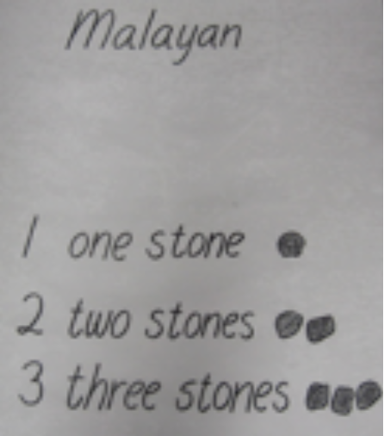

All I have to do is use one stone for each animal that I’m seeing and I can show exactly how many animals I am seeing. This chart is showing us a method used long ago in Malaya (a part of the world now called Malaysia), and the idea is to take as many little stones as the number you want to remember.

This method was used for a very long time. In some parts of the world it was used up to very recently. For example, there’s a shepherd who has a certain number of sheep and wants to be sure that he’s gathered them all together at the end of the day. In order to keep track of his sheep, he might have a little bag with one stone representing each sheep. In order to make sure all the sheep have come back, as each sheep goes into the pen, he takes out a little stone. If the bag is empty he knows that the sheep have all come in because the number of stones corresponds to the number of sheep. But are these stones special signs? These stones were used to represent numbers but they’re not special signs.

Sumerians/Babylonians:
Now let’s come to a group of people we’ve already heard about. Babylonians is what they’re called on our chart, but before them – in the land between the two rivers – we had Sumerians. We heard about them in the Story of the Ox and the House. so we already know some things about them. They lived a long time ago in Mesopotamia. Remember how the two rivers created flood plains and lots of clay? That mud was used for making bricks for building, as well as for making tablets for recording. They prepared reeds for writing, called a stylus. We said they made marks on these clay tablets with a stylus, while the tablets were still moist. The tablets would dry and they had so many of these that we could think of libraries of them. Sometimes we would find marks like these (show the Babylonian chart).

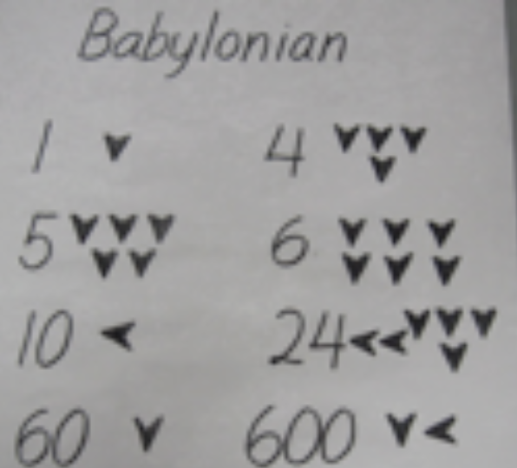

They used these marks for numbers; we can think of them as Babylonian numbers. We spoke about how their kind of writing was called cuneiform because people thought it looked like wedge-shaped writing. It reminded people of a wedge because they prepared the reeds with triangular ends. If you push in the reed once, it’s 1. Push it in twice, that’s 2. Three times is 3. We can see how they pushed it in to get 4. The fourth wedge is below, it doesn’t continue on the same row. They keep using the second row for 5 and 6. They use the same method for 7, 8, and 9 on the third row. They’re not using stones anymore; they’re using marks, but the number of marks is telling us the number of objects that they’re thinking of or looking at. If they kept going on like that, making little wedge marks to correspond to each thing they counted, it wouldn’t be different to the method used for the little stones. But it doesn’t keep going in the same way; something happens.

What happens when we reach 10? The sign changes orientation and it becomes a different mark. It is now a triangle whose little head is pointing to the left. That means that ten markings have been grouped together; now there’s a grouping of 10. This is very different to the Malayan chart with the stones – there was never a grouping there. Now we have a grouping. Understanding that, we can look at these marks: they are two tens, and 4, so all together it is 24. The 24 is being shown by using only six markings, while if it were in the Malayan we would need 24 markings or pebbles.

Let’s look at other marks. Look at the mark that says 60. It looks like the one for 1. Look at 600, they made it with a mark for 60 and a mark for 10. That’s like saying: 60x10. Later, you can figure out what the next one is saying. Cover up the answer and see if you can work it out.

While the Sumerians were developing this system, there was another human group in another part of the world, also developing their numbers. They were the Egyptians. Like the Sumerians, they were farmers, but they were different in other ways. Sumerians had lots of different cities that were like separate states, but the Egyptians were all unified under a king that they considered a god, who they called a pharaoh. They lived under a central rule, and in that situation there were lots of things for them to count, so we expect their numbers to go high. We’ve heard about the Egyptians in The Story of the Ox and the House; we heard how they painted their hieroglyphs and wrote on papyrus. They wrote special hieroglyphs for numbers.

Egyptians:

Let’s look at their number system (show Egyptian chart):

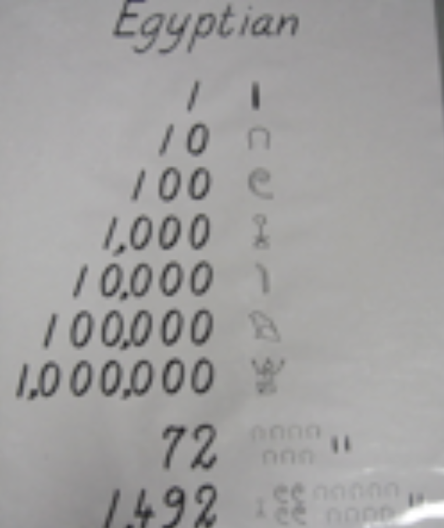

We have a 1, and they have a little line marking. Then they have a new hieroglyph for 10. What must they be doing for 2-9? They must be making more and more little marks, but when they get to 10 there’s a new sign. What does it look like? A sort of arch. What does the hundred look like? A spiral. The thousand? a flower. The ten thousand? It looks like a bent finger. (Tell the children they can look at the rest themselves.) (Point to the first number, composed of several hieroglyphs). Can you figure out what that first number is? The others? (The Egyptians don’t have a zero, but we don’t tell that to the children).

If we think back to the Malayan chart, we remember that they had no groupings at all. The Babylonians had groupings of 10 and 60. The Egyptians always had groupings of 10. Their numbers are a little like ours, in that way.

Ancient Greeks:
Did we hear about some other peoples in our Story of the Ox and the House? We heard about the ancient Greeks. Their 1 is just a stroke like ours. They called 5 “pente”. What is the first sound in “pente”? [p] Where is Greek pi on the letter chart? (Bring out the letter chart you used for the Story of the Ox and the House, and find the Greek “pi” – π ) If you don’t complete the π symbol, it’s going to look like the symbol for 5. It’s the Greek symbol for π but the second leg is not clearly drawn. What can we read on the chart is the Greek for 10? Deka. What sound does “deka” start with? [d]. They called that letter “delta”. Let’s look for the Greek “d” on the letter chart (find the Greek “delta” – Δ): It’s the same as the symbol for 10 in the ancient Greek numbers. They are using the letters of their alphabet to represent numbers. What about one hundred? Their word is “hekaton”, and the first sound in that word is an “h”. The symbol for “hekaton” is Η. Their word for one thousand is “chilioi” [khilioi]. They call the first letter of that word “chai” [khai] and it looks like a big Χ. They were using letters of the alphabet for the first sound of their number words. It’s as if we chose to use “f” for five, “t” for ten, “h” for hundred and “th” for thousand. (Note: this is called acrophonic, meaning the first sound of the word)

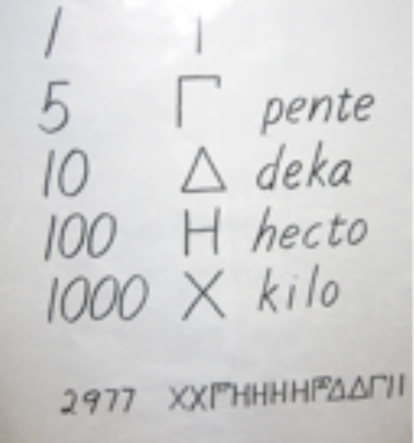

Now we can figure out what this number is! (Help the children figure out the number on the chart). What’s interesting is to look at how many groupings we can see: two. There are groupings of ten (10, 100, 1000…) and a grouping of 5.

Did you see a symbol for zero anywhere? No! We haven’t seen any zeros! They didn’t seem to want a sign that means “nothing”. Were they going to record the fact that they had no shoes or no togas or no sheep? What is there to record?

Ancient Romans:
Thinking back to our Story of the Ox and the House, who else did we hear about apart from the Greeks? We heard about the Romans. Let’s look at the Roman signs. These might be familiar to you; you might have seen them used in the environment. Where do we see these sometimes? Maybe on a watch, or on the side of a building, or for chapters in books, official documents, at the end of a film, in the Olympics or the Super Bowl… All these examples have to do with time - hours or years - but also with chapters of a book or special events. They came into existence with the ancient Romans. They are more recent than all the other peoples we’ve been talking about, and yet people just don’t agree about how these numbers came into existence. Let’s look at what people say:

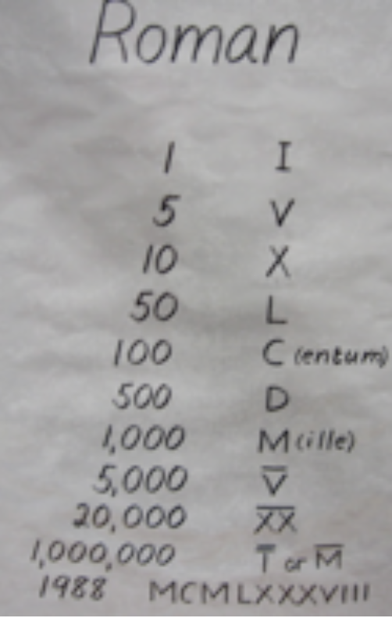

Let’s look at our first sign: I. Does it remind you of our sign for 1? Then we see this: V. This means five. Is that how we write 5? No. How could this have come into existence? Some people think it might have been the opening between the thumb and the index finger on one hand. Let’s look at the 10: X. We can think of the V as 5, and connected to it we can have an inverted V representing another 5; the total would be 10. With the signs we already have, we can make 11, 12, 13… all the way through 49. We have a new sign for 50 – it looks like a capital L. After the L, we have a C, which represents 100 (Note: the whole word for ‘hundred’ is centum [kentum] or [chentum].) The sign for 500 is D and the sign for 1,000 is M (Note: The Latin word for ‘thousand’ is mille.) You can look at the rest of the signs by yourself later – they started decorating existing signs instead of inventing new ones, in order to reach higher numbers.

There’s something else that’s very interesting… They wrote numbers for a long time like this: I, II, III, IIII, V. But then they decided to change this method a little bit. They decided to think of 4 as 5 minus 1. Then they came up with this way of writing 4: IV. You have to place the I in front of the V, so that it says 1 less than 5. Otherwise, if we did this – VI – it would be 6. When the sign for a smaller number is placed in front of a larger number, it means ‘less than by that amount’.

Let’s look at this number… It’s the type of number that you would find at the end of a film: MCMLXXXVIII. (It’s 1988). (Note: The interpretations given above help the children to remember the signs).

Another Interpretation: (optional, for second telling of story)
There are other people who think that these signs came into being in a different way. Let’s think back to our shepherd; he wanted to keep track of his sheep. He has a stick for keeping a record, and he does this by making marks on the stick. Suppose he has 16 sheep. He’s going to make 16 marks: IIIIIIIIIIIIIIII. Can you see how confusing this is? It’s very hard to stay orientated when you’re just making mark after mark after mark. What do you think we could do? We could find a way of gathering them into a group. Instead of making the fifth mark the same, we can make a diagonal mark instead: IIII/IIII/IIII/I. Now we can see much better because this allows us to see groups. We can see how we can get a V from doing that type of grouping. We don’t know how the V came into existence, but this is a good possibility. We know that shepherds used tally sticks up until recent times, so this could be an old tradition that has continued over centuries. This helps us to understand how V came to be. If you have lots and lots of sheep, this type of counting is not enough. We could do something like this: IIII/IIII/ and cross the whole thing with a long backwards diagonal. Or they could have ten sticks bound together by a long X. Either way, we would find that it makes the X for 10.

What’s interesting is that the Romans used groupings based on 10 as well, but they also had an in-between grouping of 5. This in-between grouping is very useful because it saves having to write lots and lots of signs. Another thing that is special about the Romans is that they started using subtraction to write their numbers.

Let’s look back at the charts we’ve seen, from the Babylonians through the Romans. The Babylonians came from Mesopotamia, which is in a part of Asia that’s closer to Europe. The Egyptians are from Africa. The Greeks and Romans are from the continent of Europe. These civilizations all come from different parts of the world. What about further away in Asia? There’s a very large country that’s very far from us: China.

Ancient Chinese:
The ancient Chinese also had their signs (show the chart).

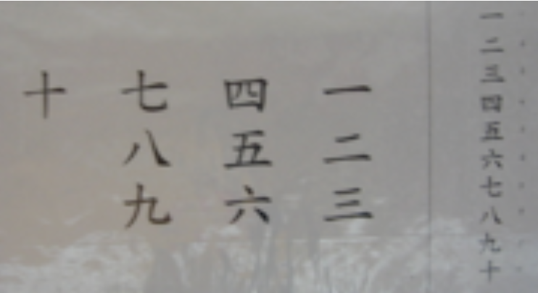

Does the sign for 1 look like ours? Yes, except theirs is lying down. What about 2? It’s two of those strokes. 3 is just three strokes. What happens then? They have a new sign for 4, 5, 6, 7, 8, 9, 10, and then they have signs for 100 and 1,000.

Have we seen anything that looks like our numbers? No. We can agree that we didn’t get our numbers from the Chinese, Romans, Greeks, Egyptians, or Babylonians. Where did our numbers come from? From a completely different part of the world! They came from India! That’s where they came up with those signs that would eventually become our numbers. To understand this, we have to go back a long time ago – more than 2,000 years ago. How did they get to us if India is a very far-away place?!

India and The Arabs:
In the seventh century, a new religion came into the world and it spread very rapidly. It was the Muslim religion, called Islam. It started off as a small group of Arabs. After the death of their prophet, Mohammed, their religion spread very rapidly as these Arabs conquered large parts of the world. Their conquests were such that they went from the Atlantic right over to India and from North Africa over to Spain. (You can get a map out if the children are not familiar with these places.)

The Arabs were great conquerors and great traders, from India over to Spain. In fact, they became a kind of bridge between the East and the West. There were always caravans going back and forth with all sorts of merchandise. As always, learning and knowledge traveled with these caravans. What’s interesting for us is that these Arabs of long ago became madly passionate about learning. Back in those times they had a great center of learning. It was the same city that’s the location for the book “1001 Nights” (aka, “Arabian Nights”). In the book, the princess who actually tells the tales calls this city something like Madanat al Salam, meaning the abode of peace. The name of this city now is Baghdad, which meant “God-Given” in Persian (Farsi). People also started to call it the Round City because it had a circular wall that was built all the way around.

The Arabian empire was so large that it was actually ruled by different people in different parts. Each part had its own ruler called a caliph. This meant ‘a leader of the faithful’. One of these caliphs lived in this city, and he was madly passionate for learning, knowledge, and books. He built a great library, and it is said that this library was greater than the famous library of Alexandria. The same city not only had this most amazing library, but was said to have the largest book market in the whole world as well. There were many books, which means many manuscripts. These came to this city written in all sorts of different languages because they were being brought from different parts of the world. There were therefore many translators who were translating all these books into Arabic.

Back in those times, the library of Baghdad, called “The House of Wisdom”, was the greatest institute of learning in the whole of the Muslim empire. There were hundreds of translators and an army of scribes, and the manuscripts that arrived there were in Greek, Latin, Hebrew, Coptic, etc. In this way the Arab world assimilated a wealth of knowledge into its own traditions.

One day, in 733 A.D. there was a caravan that came all the way from India and entered the city of Baghdad. This caravan brought gifts for the ruling caliph and among the gifts was a very special book, which had been brought from India. It was translated immediately into Arabic. Inside the book there were the numbers that were to become our numbers, brought all the way from India. About 200 years later they looked like the numbers on the Old European chart.

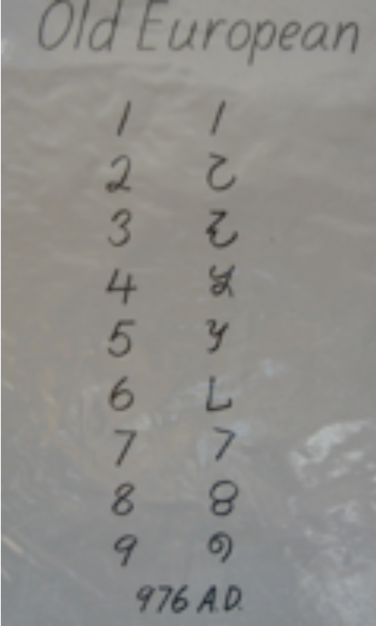

You can compare them with ours to see how ours could derive from these in a way that we couldn’t see in the earlier charts. If I were to say these numbers out loud they would sound like this: eka, va, tre, quator, palken, sat, sate, nava…

The Origins of Zero:
There’s a special number that came over from India; it was a particular sign that is not in the chart. It was the number zero, which came with its own sign. The Indian word for zero was sunya [shunya], which meant “empty”. They represented it by a little circle – “o”. When the Arabs translated the word sunya, it became sifr. This is the Arab word for empty and they used the same sign. We get some of our own words from this word. In Latin this became zephirum. From that it went to Italian, which became zephiro, which eventually became zero in English. Our word for zero can be traced back to the Arab for “empty”, which was a translation of the Indian word for “empty” (Note: we also get our word cipher from this, meaning “digits”).

Once the Arabs had these Indian numbers they took them everywhere including to Spain. That’s how these numbers entered Europe. Let’s go back in time and see the sorts of changes that took place in the signs over time, going right back to 300 BC. Notice that the zero was included in 876 AD. By the time the Arabs brought the signs with them, the zero was already there. How many symbols do we need in order to write all of our numbers? We need 1-9 and 0, so that’s 10 numbers all together. With 10 little symbols we can write all of our numbers. 1-9 is not enough; we need to have the zero. Do you think that 10 signs is a lot in order to write any number? No, it’s actually very few signs.

The Greeks had a number system that we looked at, and they also had a different system where they used letters of the alphabet for numbers. They had 27 signs, but they couldn’t go forever with these signs. Instead, we have 10 signs and we can go on forever writing numbers. Is this really true? Is there really no limit? We can think of it like this: (write 1, then one zero, then keep adding zeros and asking the children until they don’t know any more and keep adding zeros. Point out we can go on forever and ever). How extraordinary!

What is it that makes it so easy, simple, and clear? It's zero. It’s strange to think for how long human beings have had signs for numbers and yet how long it took for us to have the zero. That might seem strange to us because we’re so used to the zero, but for early humans what need was there for a zero? What use is something that represents empty? It’s interesting to think that it was the Indians who thought of treating zero – nothing – as a number, and devised a sign and passed it on. I wonder what was special about their way of thinking, their way of life, that they thought that zero should be a number?

Once zero was part of these signs that we can think of as Indian-Arabic (or Hindu-Arabic) signs, we have a really clear way of writing and working with numbers. But the funny thing is that people are slow to change. When these signs first came into Europe, people were used to working with the Roman method. They didn’t want to change and they resisted, so it took a long time for people to accept the signs and start using the zero. But when they did, everything became much easier. The key to the simplicity of our numbers is zero; it’s nothing. That nothing, that zero, permitted the story of mathematics to develop in a different way.

Follow-up activities:
- Re-tell the story after a few days, either in its entirety or focusing on one particular aspect (such as Roman numerals or the importance of zero).
- The children can explore number systems in much greater depths later on (in a couple of years, when they are more advanced). This is the true follow-up of the story.

Optional supplement to this story: Math timeline (purchase here)

Notes for adults on the Story of Numbers

- Zero is important for two reasons. Firstly, it is a placeholder. People were not doing mental arithmetic with older methods because it was cumbersome. Our zero helps us do mental arithmetic. People have used a concrete way of working with numbers, including working with pebbles in sand, and then the abacus. Calculus comes from the Latin word for “pebble”. They were not manipulating their signs; they were manipulating objects. Numbers were just used for recording. It is astonishing that we should expect our children to work abstractly, even though adults for centuries have used concrete tools. Most peoples did not use place value; they translated their answer into signs without concern for place value. Only the Babylonians had place value and the sophisticated Babylonian system did use zero as a placeholder.

- Secondly, it was important as the symbol for “nothing”. The Indians used zero as a placeholder but also as a concept of a number that was nothing: zero as coming before 1. It was thought of as a genuine number. Indians have a tradition of being excellent mathematicians up to this day.

- The book came from India in 733 AD.

- The Indians also developed negative numbers before we had them in Europe.

- The Mayans also thought of zero as a number, but we didn’t get our numbers from the Mayans so we tend to ignore them.

- Zero as a placeholder comes after 9; when zero has a value it comes before 1.

- The Story of the Ox and the House and the Story of Numbers belong to super-nature. The story of GWHNH, The Story of Life, and The Story of the Coming of Human Beings are authored by Nature. The former are consequences of human work, effort and thinking. It’s amazing to think of all the different parts of the world that are involved. In some sense we are indebted to many different kinds of peoples. The fact that we all use these Indian numbers internationally means that we are all indebted to this far away, long ago group of human beings.

- In both cases, the case of the alphabet and the case of our decimal notation, we see systems that come into existence that are simple, easy and accessible to everyone – truly democratic. You don’t have to dedicate your life to studying in order to read/write or work with numbers. Precisely because they are so simple, they are at the reach of children as young as Children’s House. We can try to carry out operations with the other systems. Some people like to include this challenge in the story. However, the people who were using these signs weren’t working with these numbers abstractly; they were using concrete aids. So why should we try to do abstract work?

- It took a long time for human beings to accept and change to this new system. Human beings tend to want to hang on to what’s familiar.

- We should not exclude children if they haven’t had the necessary experiences. Remember that the children are going to hear the story told many times, and they will get something interesting each time they hear it. There’s a limit to how much we should provide in each telling. Each child will take out of the story what he can and will hear it every year.

- It is the fifth fable, and therefore some time goes by in the elementary classroom before they hear it, so they will have time to work with some of the materials.

- If some children have already developed a mental barrier for math, hopefully they will be inspired by the story. If we are seriously concerned, we can give a smaller group a smaller story where we can focus only on our numbers.

- All the people have some idea of numbers, even if the idea is limited to low numbers and even if it isn’t always in written form, because the need for numbers arises in daily life.

- Once we pass from record keeping of a 1 to 1 correspondence type being done with objects, to some form of notation, we see the universal use of the symbol for 1. That symbol for 1 reminds us of a finger, a notch, score, a tally (a little mark in other words) and with that notation of these little marks we start to see a grouping.

- A very old wolf bone has been found, about 30,000 years old, which had a series of notches marked into it and these notches were arranged in groups of 5. There was a very special notch after 25 as a clear indication of the use of 5 for grouping or base.

- Once the numbers/notches are grouped, it is easy to recognize numbers.

- As regards groupings, the most common groupings we saw were: ten and five. Ten is easy to understand because we have 10 fingers. The Mayans have groupings of 20, probably because they used their toes as well. This means we have a biological basis for 5, 10 and 20. There’s also the sexagesimal system, used by the Babylonians and inherited by us in the way we measure angles and tell time.

- We didn’t see the Greek symbol for ten thousand on the chart, but their word was myrioi. We would expect the sign to be the Greek Μ, but originally it meant a number that was so huge that it couldn’t be counted. It’s non-specific. When they had a need for a higher number, they took that one and applied a specific meaning of 10,000. That’s when the Greek Μ began to be used for 10,000.

- If we think of these groupings emerging from our own bodies, from a biological point of view (finger counting), then the only group that is not following this is the Sumerian/Babylonian culture. They wanted a high base; they had two bases because it was the coming together of the two systems. The Sumerians’ culture dominated even when they were conquered, because they were very advanced. The Sumerians used a very high base because they had a strong interest in astronomy and recording. Their records are considered to be quite amazing to this day.

- The actual notation is also important. More specifically, what’s important is that when you want another number, are you just repeating the same sign over and over or is there a change in symbol, and when does the change take place? If you see that the number changes for 1 and for 10, this means that the numbers between 1-10 are just the number 1 repeated over and over. It is very difficult to see quickly what a number is if the same symbol is repeated over and over.

- We have increasing trouble recognizing immediately what number we see when there are more than 5 of that same symbol. That’s why Montessori made the black/white bead stair. This is why the sub-grouping of 5 was born. Other people, like the Egyptians, arrange the symbol in different ways (this serves the same purpose). What is remarkable is that we do not repeat; we change symbol every time. If all the units have a different sign, we can recycle them, and that’s exactly what we do from 10 onwards. We hold the place with the zero. The use of the zero guarantees hierarchical value and makes it simple.

- Questions to consider for each system of numbers: Are they recycling signs? Are they using zero? Are there different signs for each unit? What’s the grouping/base?

Sources:
From one to zero: A universal history of numbers. Georges Ifrah

Number stories of long ago. David Eugene Smith (for children)

Numbers and Numerals. David Eugene Smith and Jay Ginsberg (for children)
(available from the National Council of Teachers of Mathematics)

The Makers of Mathematics, Alfred Hooper (out of print)

